CURRICULUM VITAE

Dr. Adarsh Dhavaleshwar 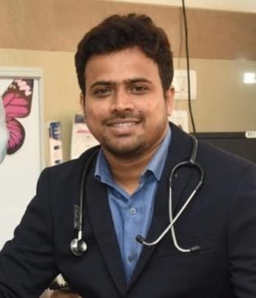
MBBS, MD(Paediatrics), Fellowship in Neonatology (NNF), advanced and basic NRP trainer
Treasurer IAP Branch Belagavi

Addy1577@gmail.com
Contact Number: 9686538711

ACADEMIC CREDENTIALS:
QUALIFICATION | INSTITUTE |  | YEAR
MBBS | Karnataka Institute of Medical sciences , Hubli | 2007-2013
MD (Paediatrics) | Grant Government Medical College, Mumbai | 2015-2018
NNF Fellowship in Neonatology | Seth G S Medical college and KEM Hospital Mumbai | 2019-2020
NRP ToT |  | 2024

PROFESSIONAL EXPERIENCE:
POST HELD | INSTITUTE | YEAR
Assistant Professor | JNMC Medical College , Belagavi | Septmber 2023 to till date
Assistant Professor | KIMS, Mangalore | March 2022 to Septmber 2023
Junior Consultant in NICU | Cloudnine Hospital Jayanagr ,Bangalore | December 2021 – November 2022
Senior Resident, Department of Paediatrics | Seth G S Medical College and KEM Hospital ,Mumbai | August 2019 - August 2020
Senior Resident, Department of Paediatrics | LTMMC Sion Mumbai | July 2018 - July 2019
Junior Resident, Department of Paediatrics | Grant Government Medical College, Mumbai | June 2015 – June 2018
Assistant professor in department of pediatrics | Kanachur institute of medical sciences | June 2022-sep 2023
Assistant professor in department of pediatrics | J N Medical College Belagavi | September 23 – Sept 2025
Consultant pediatrician | Soukhyada hospital Belagavi | September 25

POSTER PRESENTATION :
‘Acute Nectrotising Encephalopathy in child with H1N1 infection’ at RESPICON 2017, held in Bangalore.

PUBLICATIONS:

Vitamin D levels in normal newborn and its clinical correlation published in International Journal of Frontiers in Medicine and surgery Research2023

Comparision between SNAPPE-2 score and CRIB-2 scoring methods in predicting neonatal mortality in NICU published in Journal of Perinatal and Neonatal Care.

WORKSHOP/CONFERENCES:
- Participated in th 11th IAP Pediatric Quiz for Post Graduates Divisional round held at LTMMC &LTMGH in 2017.
- Participated in advanced NRP provider course in 2021.
- Participated as a Delegate in the CME on “Wilson Disease- Bench to the Bedside”, held in Mumbai.
- Participated as a Delegate at RESPICON 2017 held in Bangalore.
- Participated as a Delegate in the workshop on Antibiotic Prescription Made Easy in Mangalore.
- Participated as delegate in National Symposium on PEDIATRIC ECZEMA and ALLERGY in Mangalore.
- Participated in KAR-PEDICRITICON 2022 held in Mangalore.

PERSONAL DETAILS:
- Date Of Birth: 08/06/1989
- Father: Mr. Rajashekar Dhavaleshwar
- Mother: Mrs. Mahananda Dhavaleshwar
- Address: C/o R B Dhavaleshwar ,Yadwad Tq-gokak, Dist- Belagavi

